horizontal line

**Adding Users/Role/Groups**

Users/Role/Group configuration can be performed using the settings section under business central.

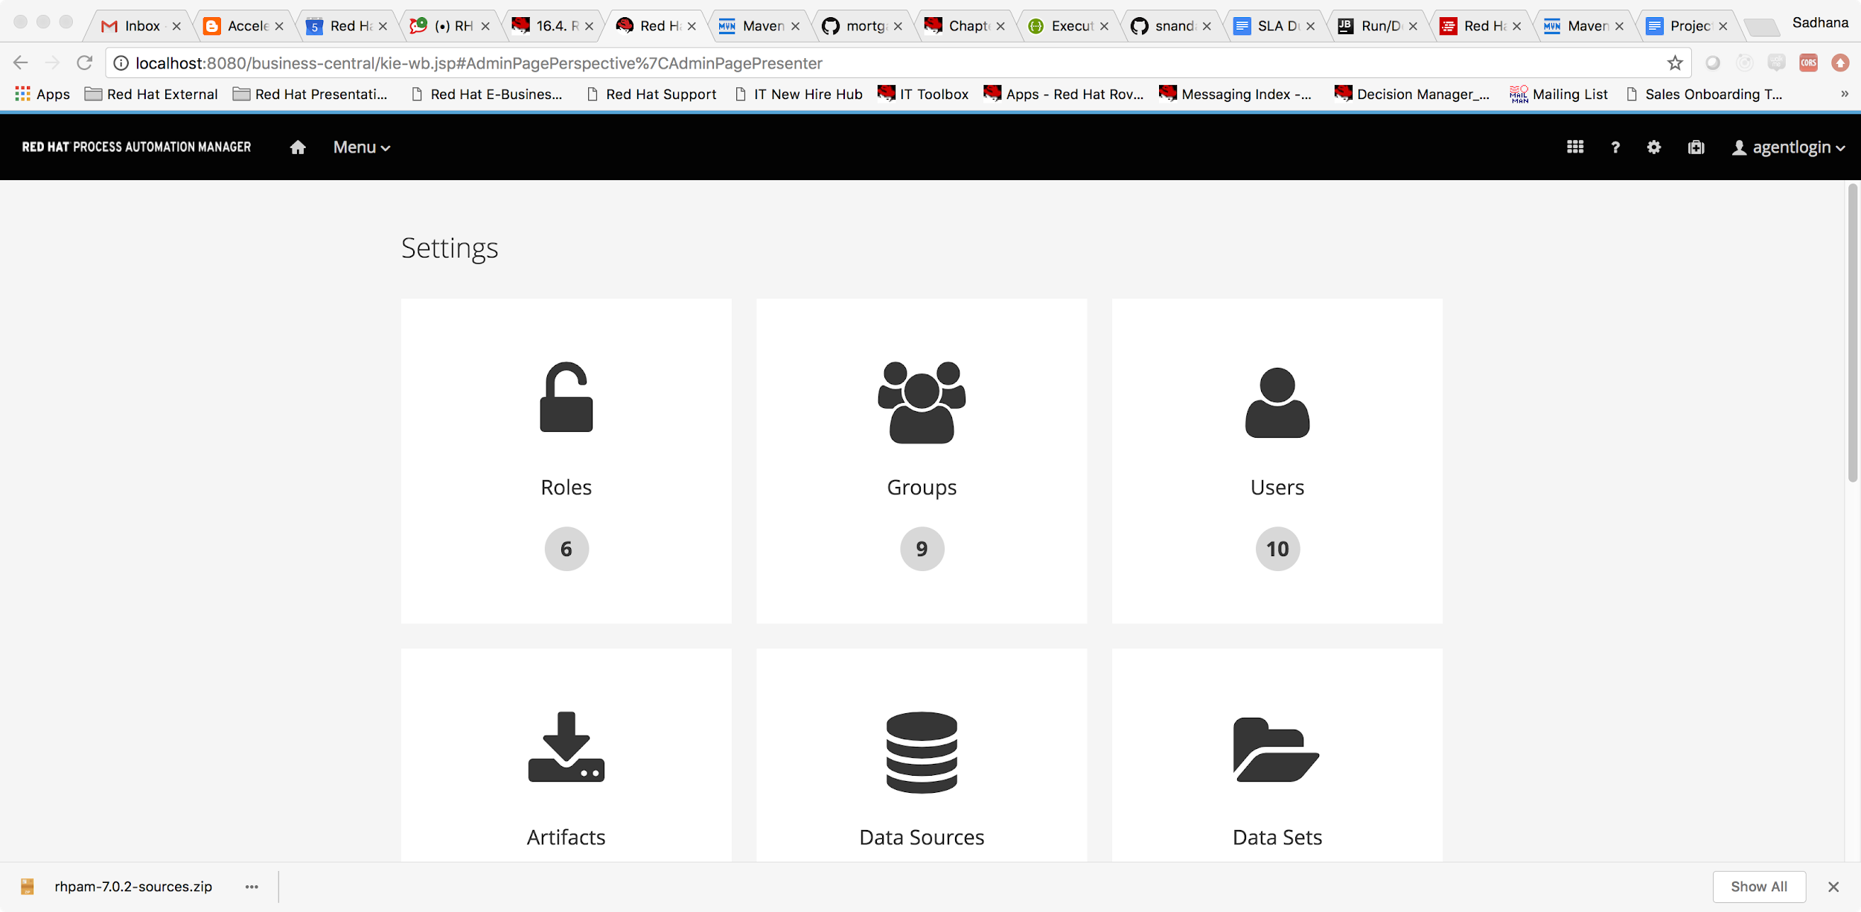

Let us create a new user named mortgageManager, and have a manager role attached. We will also add him to a group called mortgageGroup and show we can assign to a process.

Click on the Users widget.

Click on the New user.

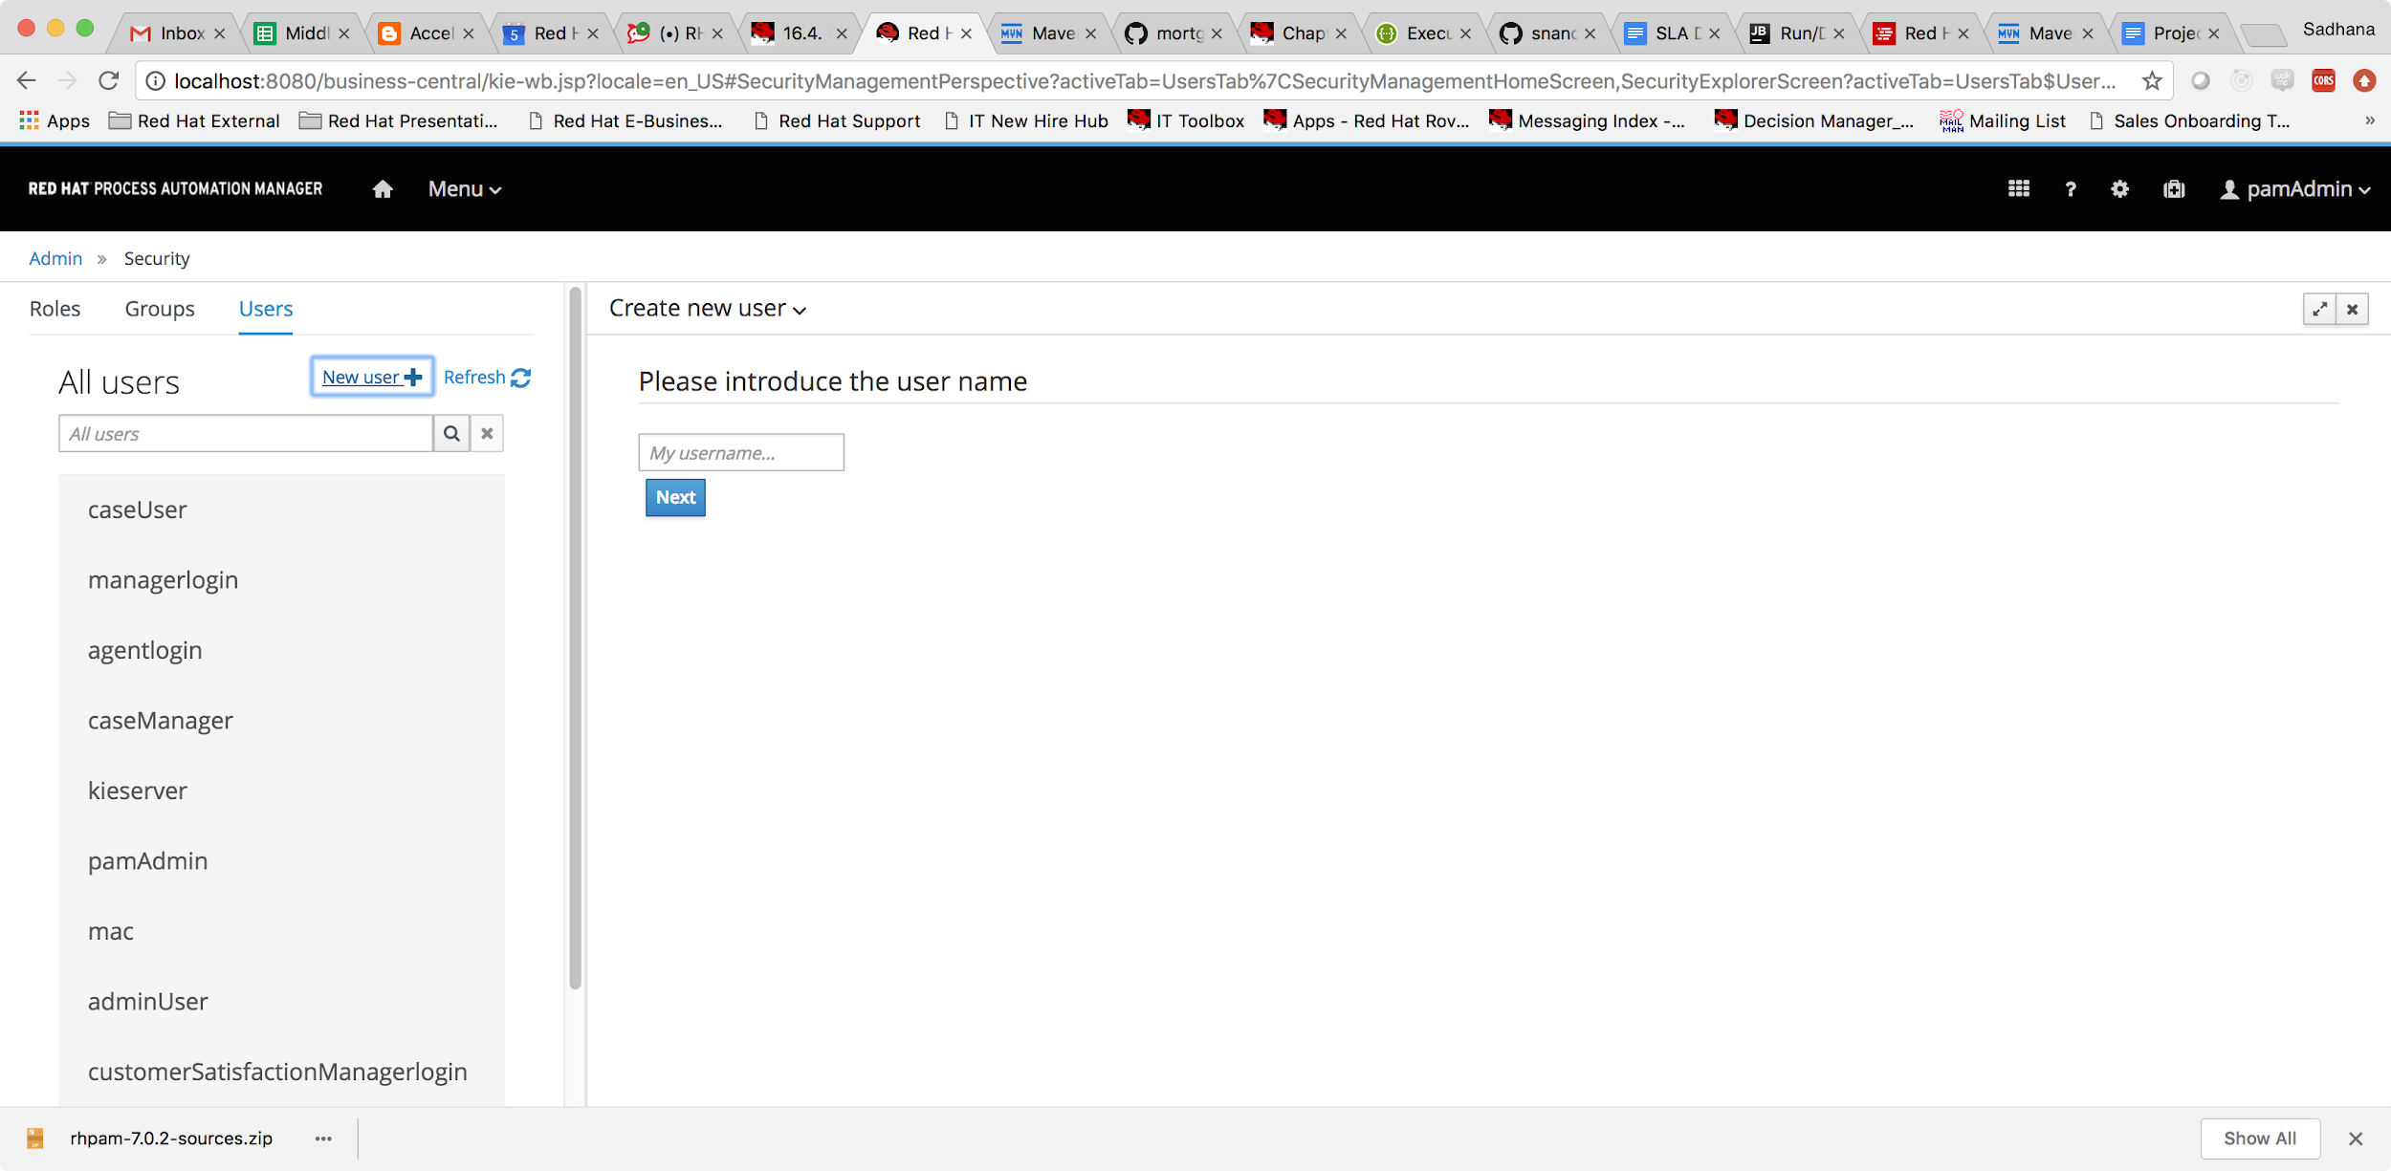

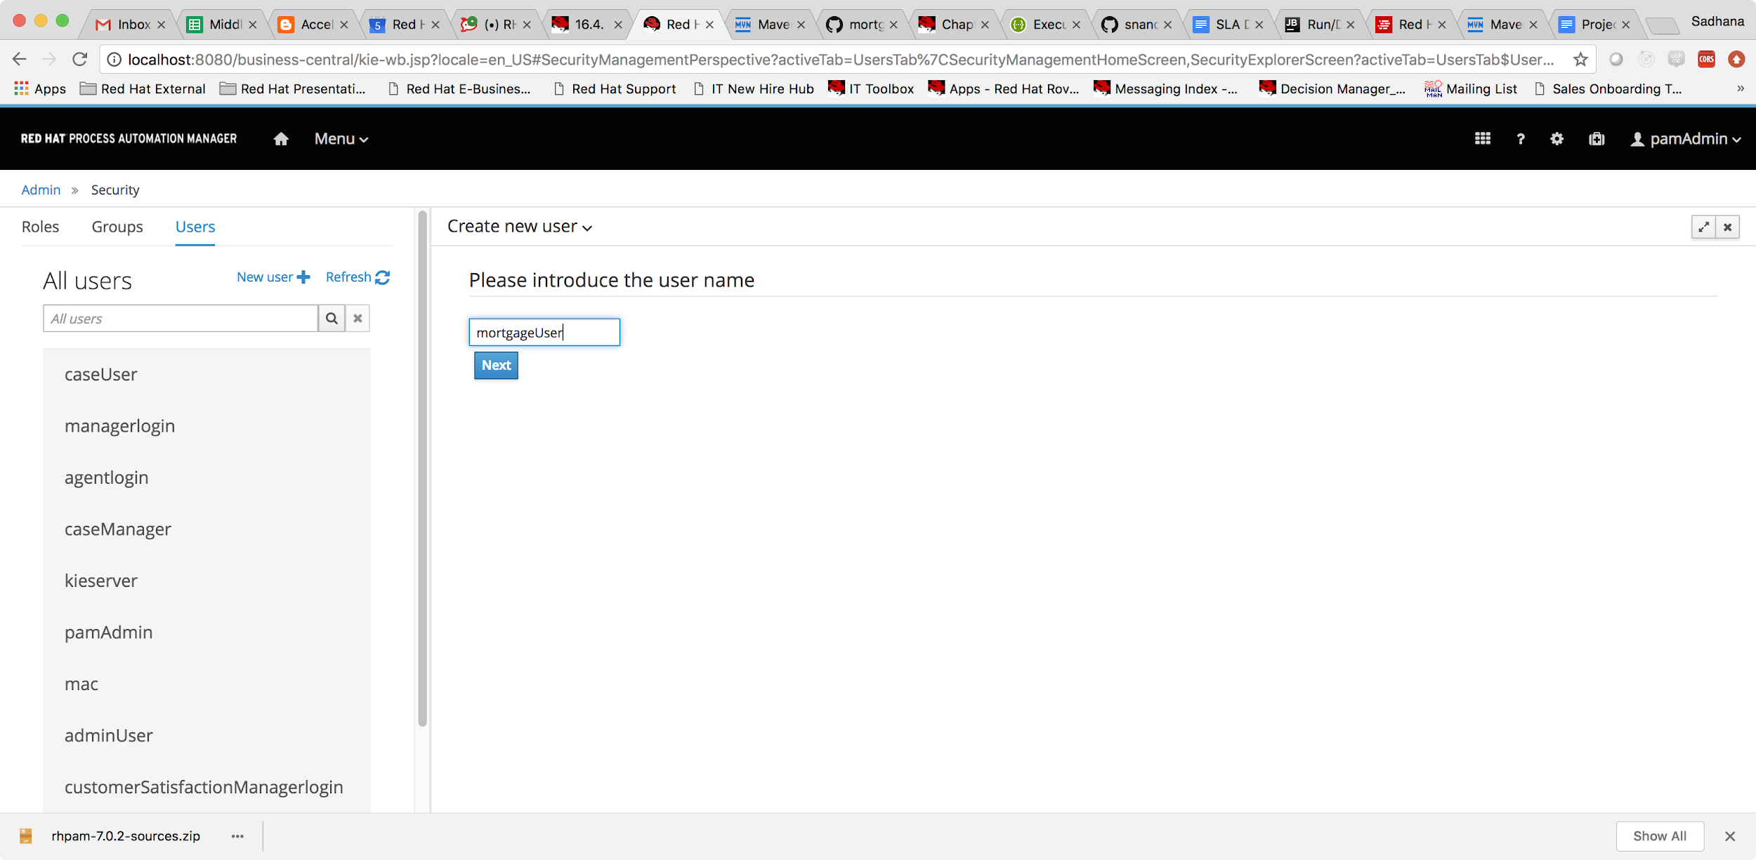

Now we can add a role to this user, click on the roles tab

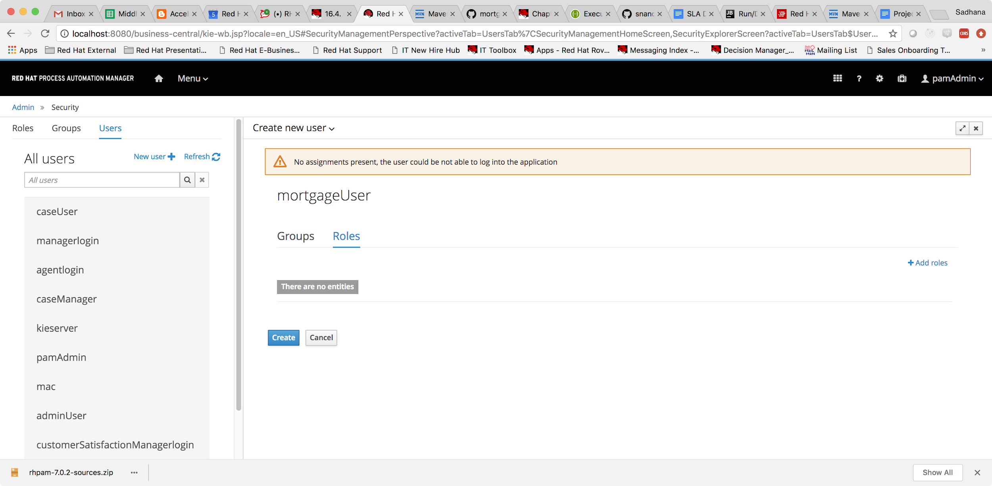

Let us add the manager role to the user.

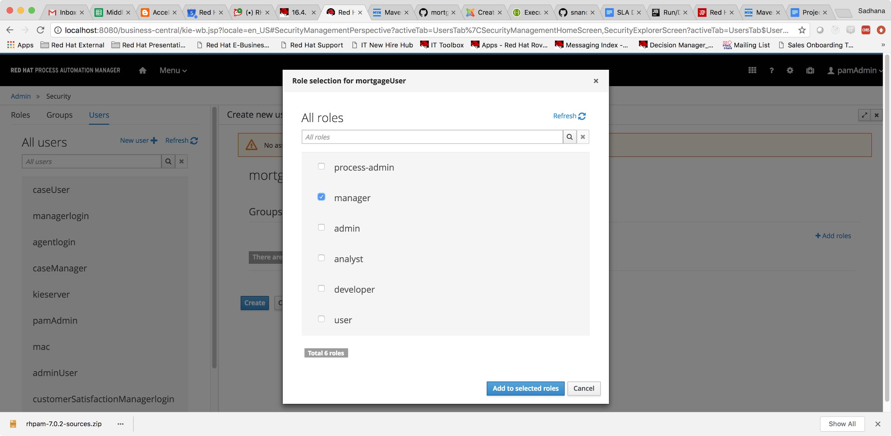

Add the selected role and click on create.

The system now prompts us to set the password for the user created.

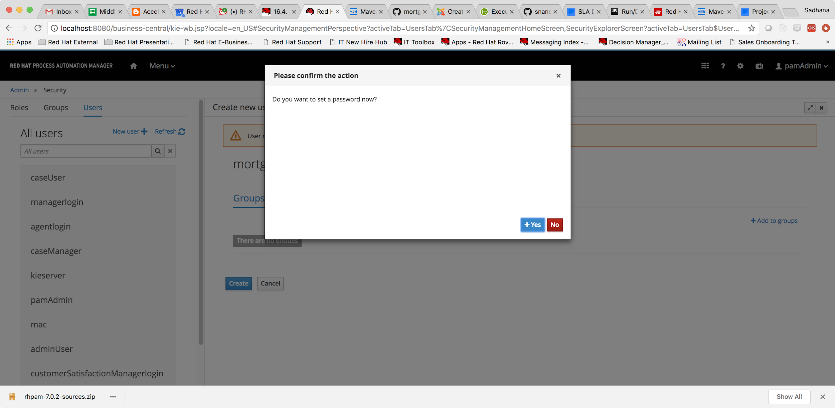

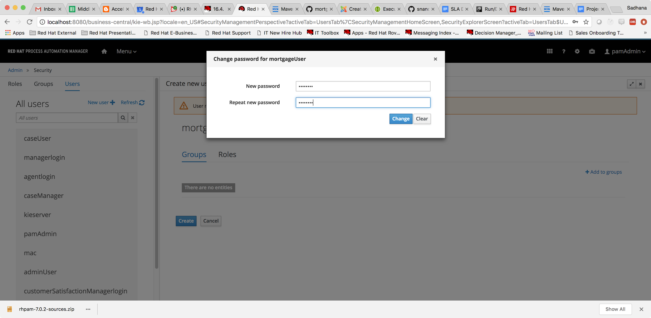

You can now see that user is created, and shows up on the left pane.

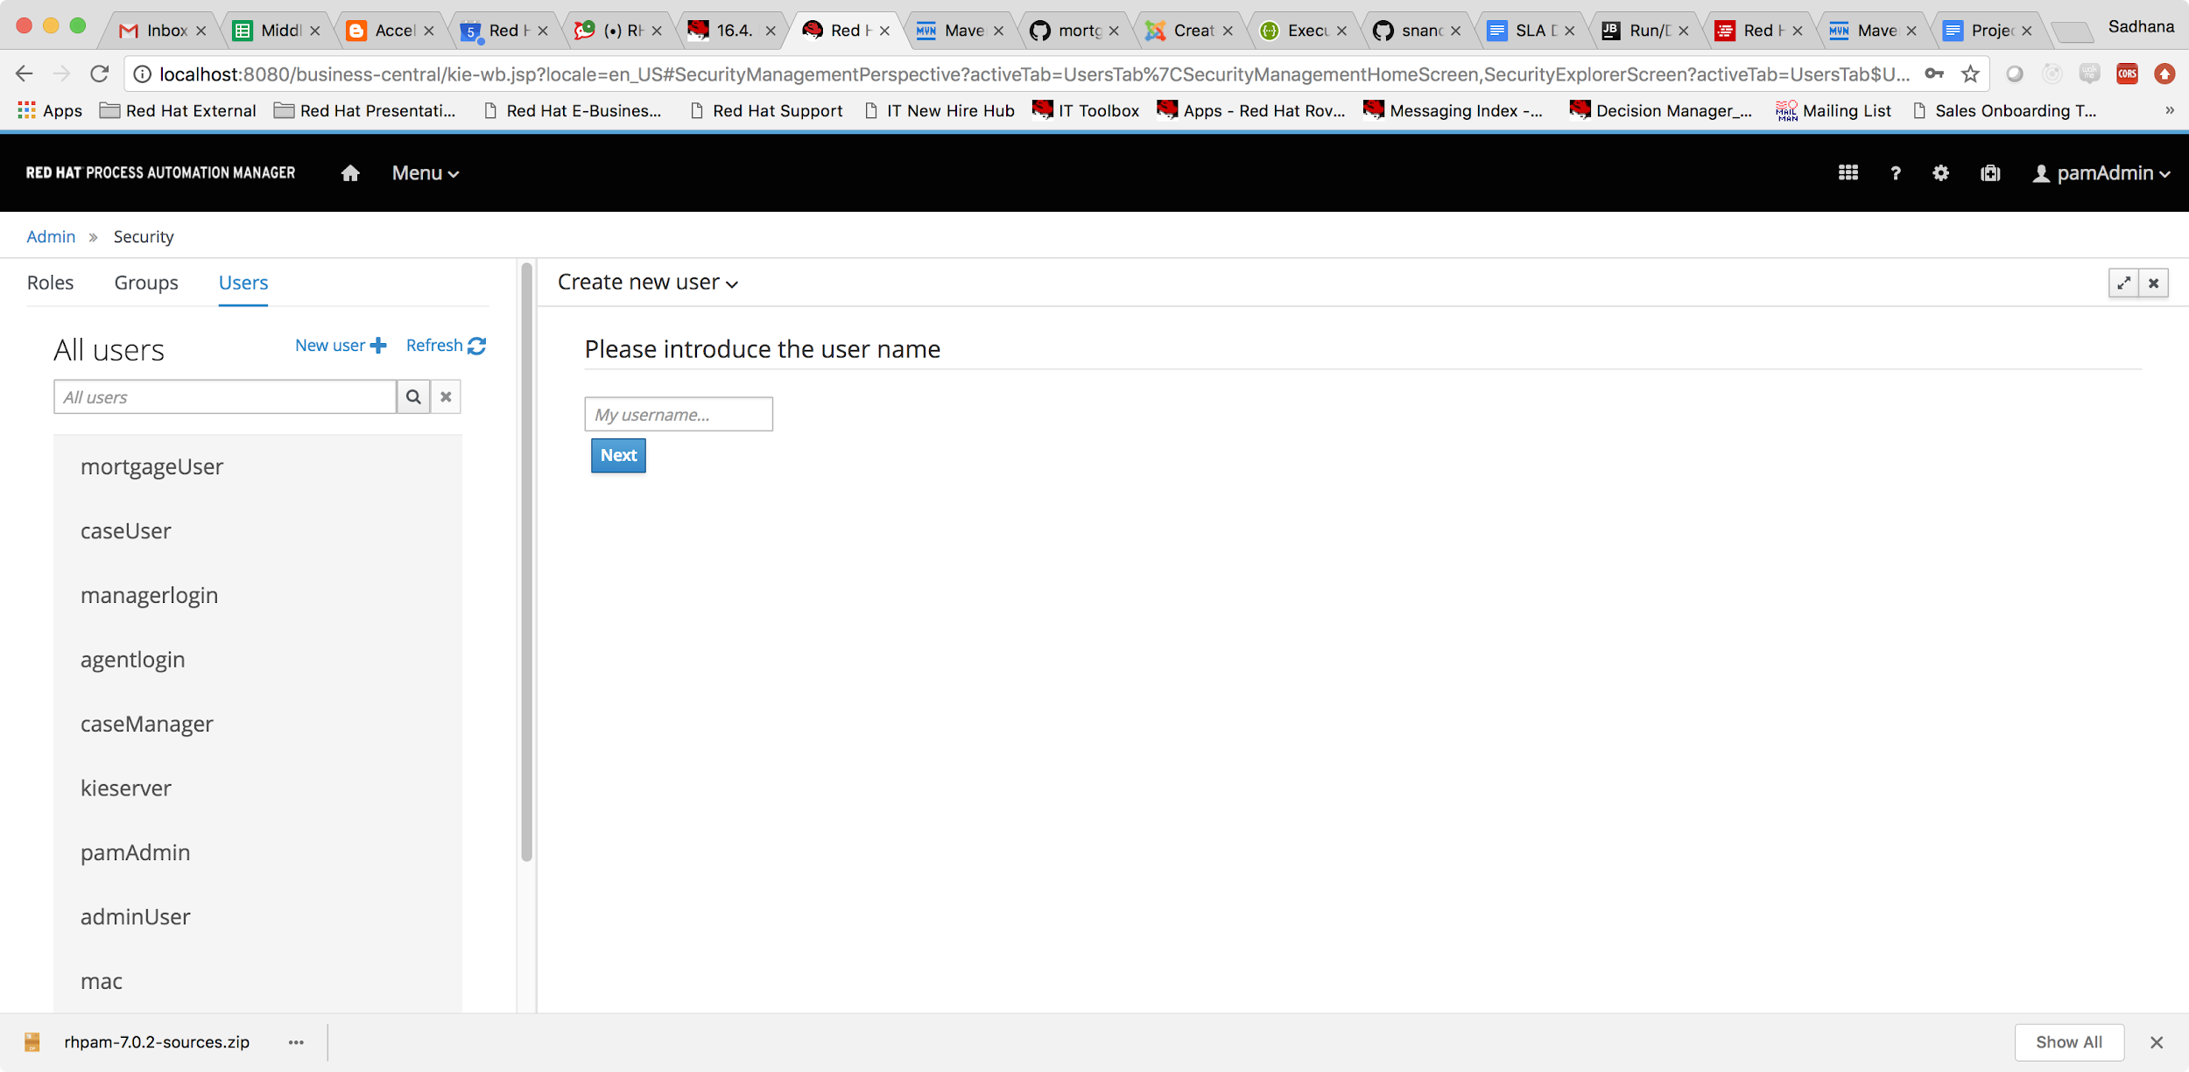

Now click on the Group tab from the left pane.

Choose the New Group option so that we can create a new user group.

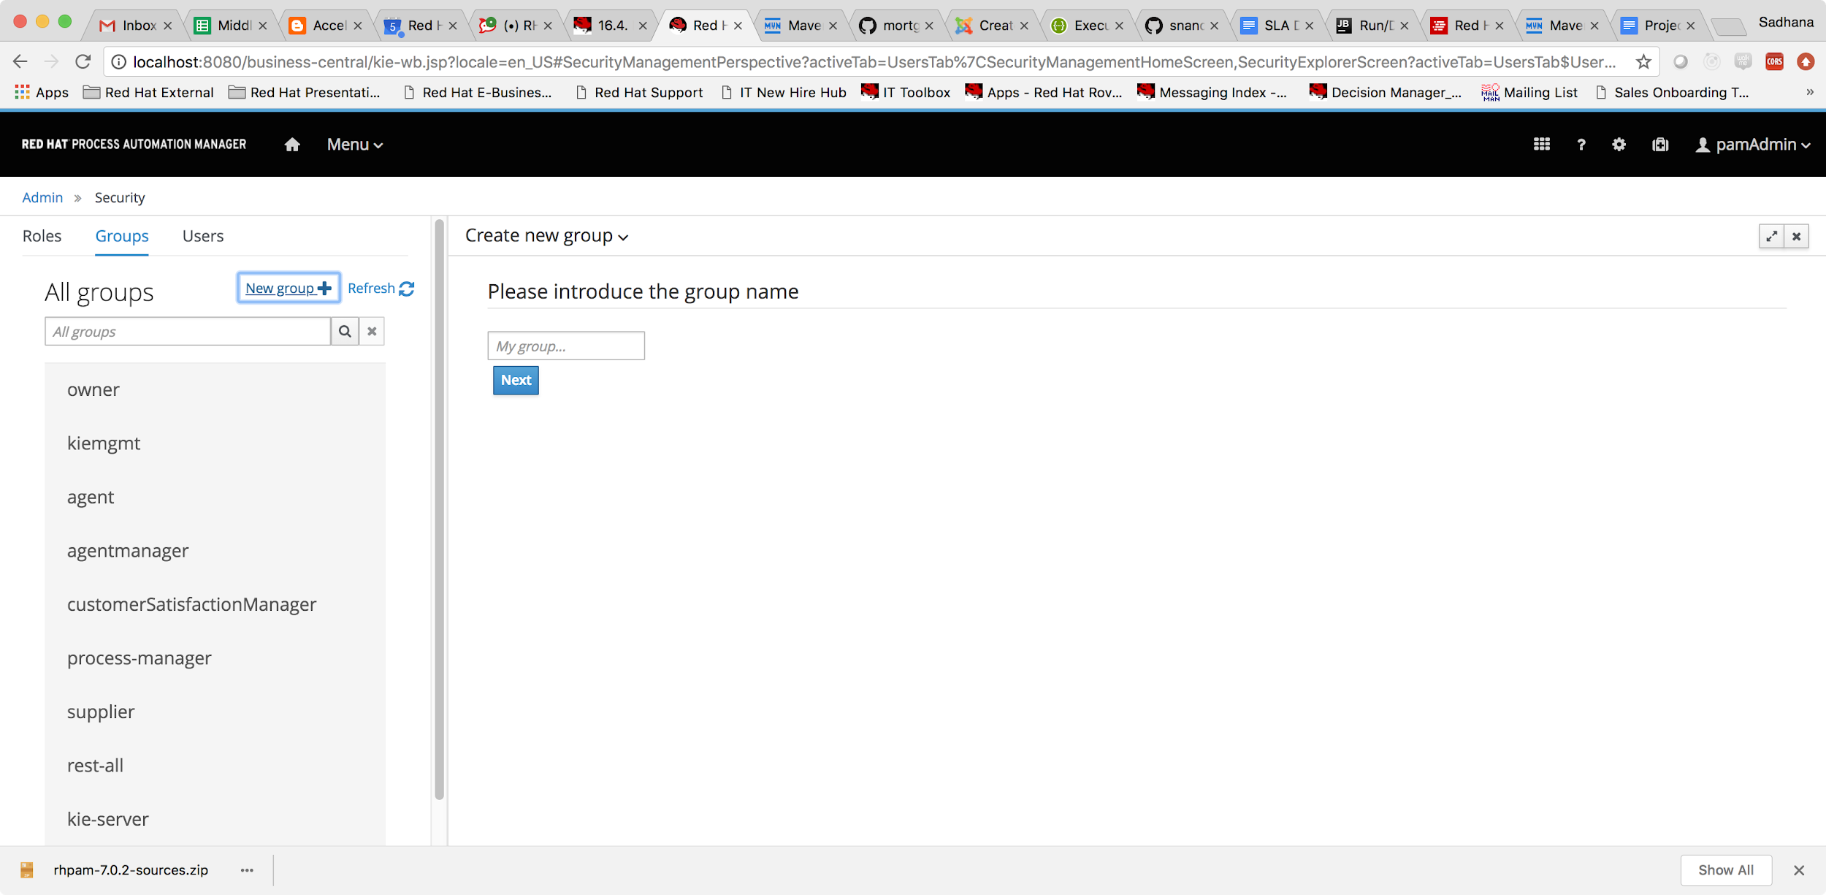

Add the name of the user group and click next,

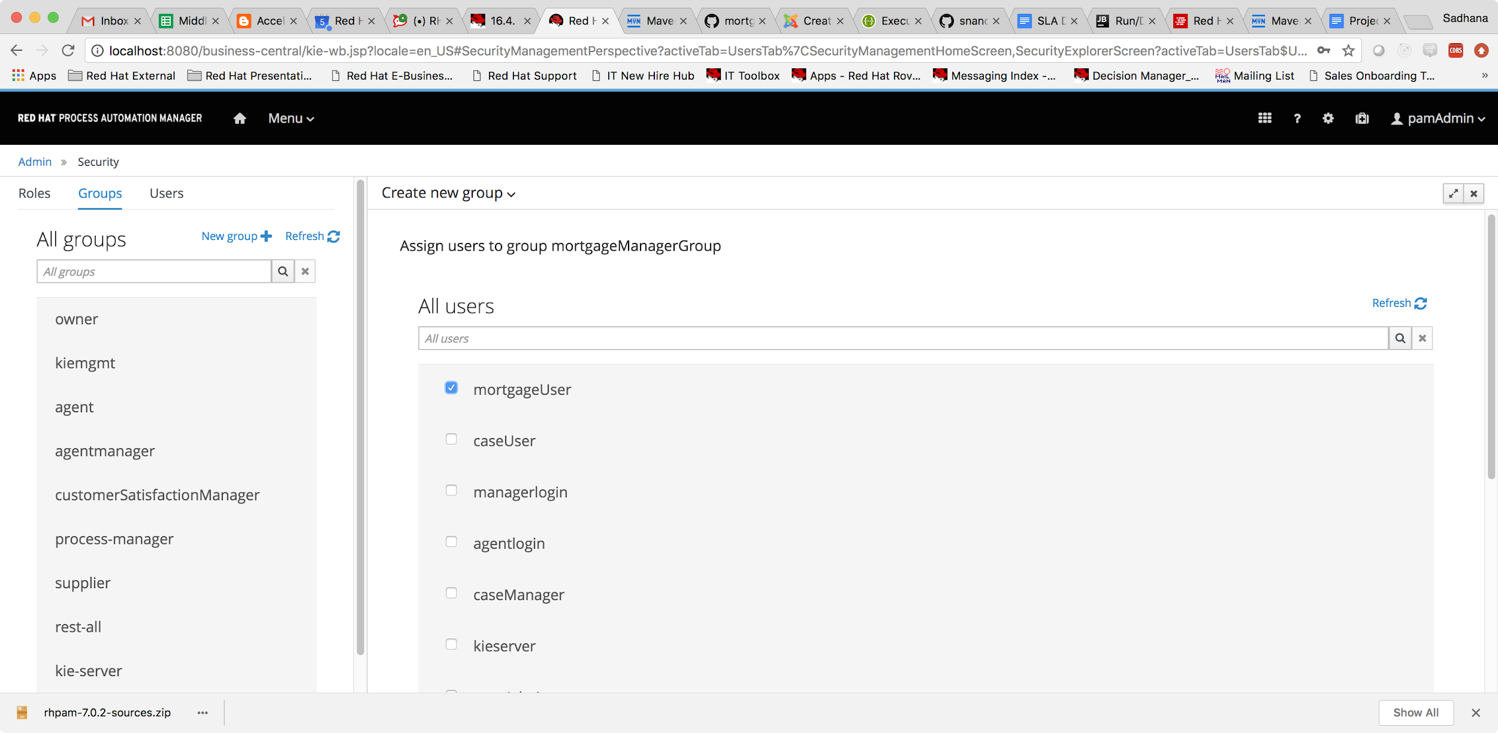

Choose the user we just created and click on ok. You can now see that the new group has been created and shows up on the left pane.

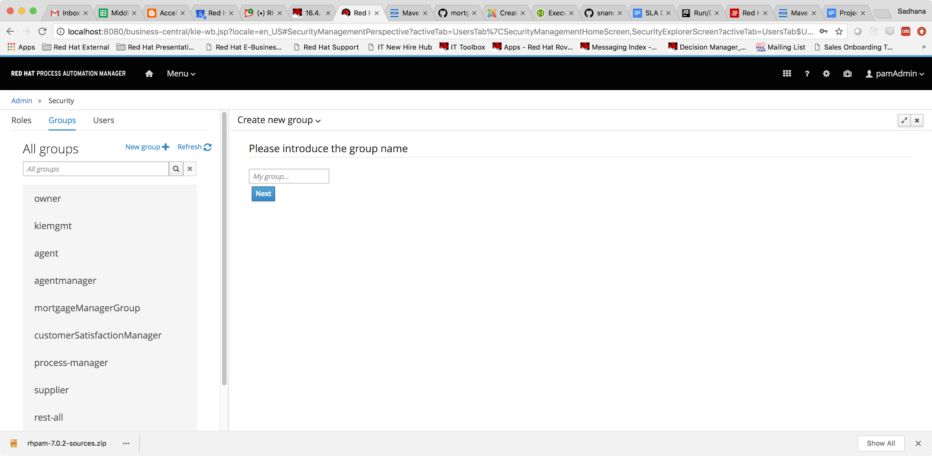

Now the user/group can be assigned to a human task on the process.

Open up the Mortgage process -> choose the correct data form user task ->

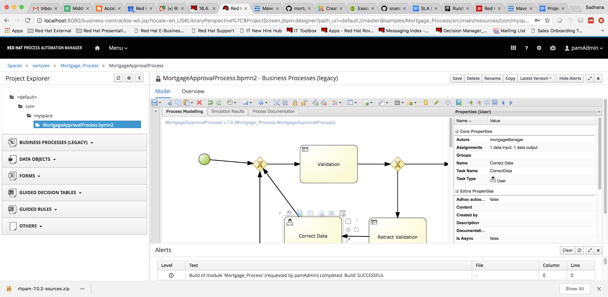

Add the name of the user we created in the Actors property of the user task. Alternatively if we have multiple users with the same role under the group mortgageManagerGroup and we can assign it any user from the group we can configure as follows,

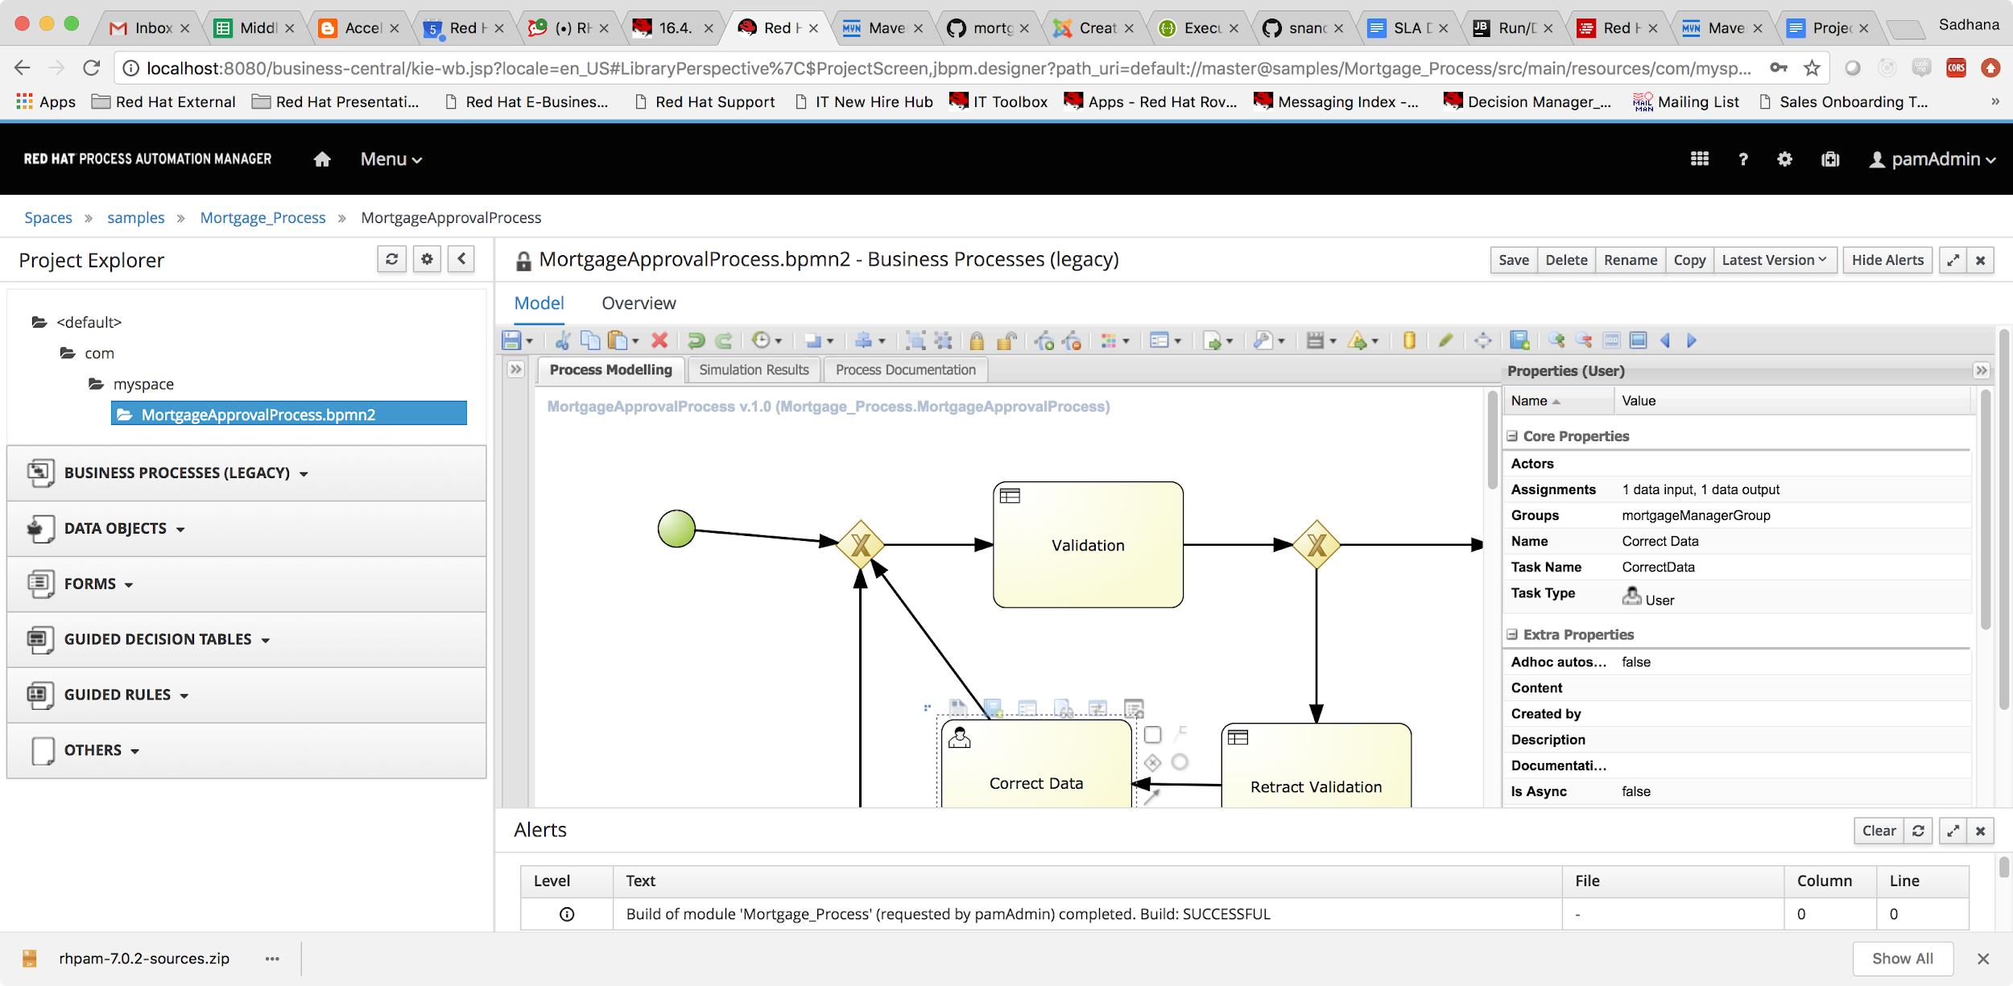

Now logging in with the credentials for the mortgageManager, shows up active tasks assigned to the user for taking action under the task inbox.